**Update on the Use of Deployable Assets for the NPSBN**

May 13, 2015

In order for the Nationwide Public Safety Broadband Network (NPSBN) to support public safety and first responder operations whenever and wherever they need broadband communications, deployable assets will comprise an important part of the network. As desirable as it would be to have reliable terrestrial coverage everywhere in the United States, this is just not practical given a limited budget. In fact, FirstNet has suggested baseline coverage performance areas for each state, based on specific public safety usage and risk factors. Those areas that do not exhibit an anticipated consistent need for public safety response are designated as candidate areas for coverage using a deployable unit in the event of an incident. Those baseline areas for the State of MD, as suggested by FirstNet, are designated by the gray shaded areas in the figure below.

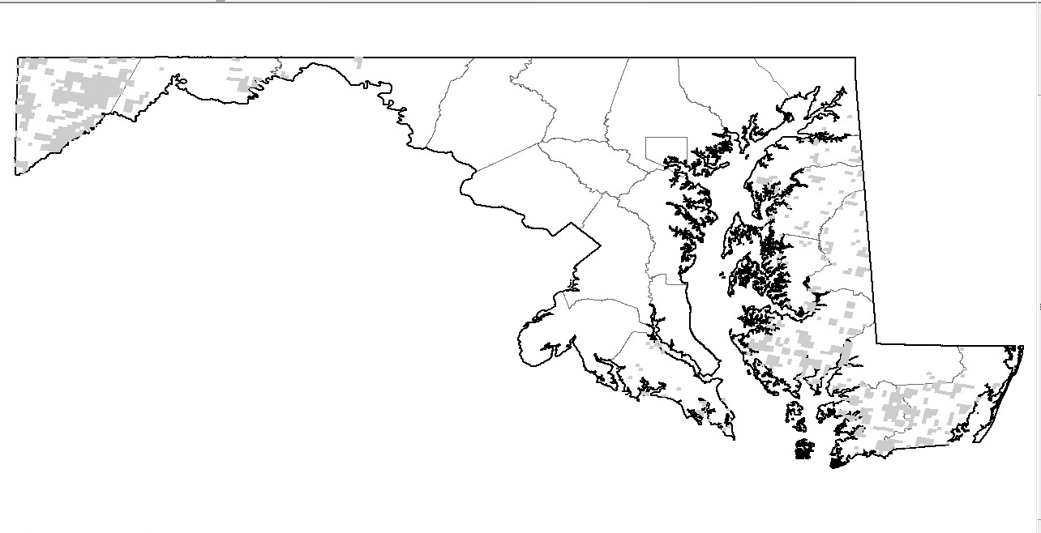

In order to support the mission of the NPSBN, a number of vendors have identified potential deployable solutions that would be applicable to the network. These solutions can be grouped into three main categories:

* Trailer-Mounted:
  + Typical use: Long term; Medium term; Incident Recovery;
  + Up to 1000 Concurrent Users;
  + Coverage Area: 1-7 mile radius depending upon site and antennas;
  + Backhaul Requirements: Likely Satellite based.
* Lightweight Fixed or Semi-Fixed:
  + Typical use: Long term – rural areas and high availability;
  + Up to 1000 Concurrent Users;
  + Coverage Area: 1-15 mile radius depending upon site and antennas;
  + Backhaul Requirements: Likely Commercial Microwave.
* Vehicular or Backpack:
  + Typical use: Immediate; Incident Response:
  + Supports from 20 to up to 64 Concurrent Users:
  + Coverage Area:.25 mile radius depending upon site and antennas:
  + Backhaul Requirements: Commercial Cellular, In-Band LTE or 4.9 GHz:
  + Some have wireless mesh and Self Organizing Network (SON) capabilities;
  + Some aerial-deployable via balloon.

In an effort to further investigate the viability of deployable units, the State of New Jersey was tasked to explore the capabilities and options for deployable assets as the focus of its Broadband Technology Opportunities Program (BTOP) grant and spectrum lease agreement with FirstNet. Currently, the State is in the process of procuring a total of 29 deployable assets; including Cell On Wheels (COWs) and System On Wheels (SOWs) configuration. The assets will be deployed in three proof-of-concept areas (the Route 21 Corridor in north central New Jersey, Camden in southern New Jersey, and Atlantic City on the Jersey Shore.), in addition to some held in ready standby as necessary throughout the State. The majority of the assets will be trailer-mounted with the following characteristics:

* Tandem axle trailer approximately 8’ wide by 16’ long, but less than 6’ 6” high when stowed;
* Estimated weight of 7000 pounds;
* 60’ segmented extendable tower;
* Three sector Multiple Input Multiple Output (MIMO) antenna;
* WiFi and Microwave antennas can be mounted to the extendable tower.

As of this date, the State has developed an RFP for the equipment, made a vendor selection, executed a contract and recently taken delivery on several units. A picture of one of the units appears below.

